**ACKNOWLEDGEMENT**

First, we express our gratefulness to almighty ALLAH for His blessing which makes us possible to complete the project.

We are grateful and wish our profound indebtedness to **TanjilaFarah**, Senior Lecturer, Department of ECE, North South University, Dhaka. Deep Knowledge & keen interest of our supervisor in the field of “Deep Learning” to carry out this project. Her guidance, constant supervision, enthusiastic encouragement, sagacious advice and an effective surveillance throughout the entire period of the project have made it possible to complete this project.

We would like to thank our entire CSE 299 course mate in North South University, who took part in this discussion while completing the course work.

At last we must express our sincere heartfelt gratitude to all the staff members of the Computer Engineering Department who helped us directly or indirectly during this course of work.

**ABSTRACT**

Our main idea is to create a general platform for making the process of searching job according to one’s accolades and desire for job. Our site will be containing people who wants to search for job and also who are willing to provide job according to the vacancies in company.Technologies that are used in this project are MySQL, PHP, HTML, CSS, Bootstrap. We also used API in our project to search for the convenient job for the seeker. We used PHP as a domain of a framework. We use HTML to create the webpages and CSS to design the webpages. MySQL stored all the data of the website.We applied Bootstrap as an open-source toolkit HTML, CSS, and JavaScript framework for developing responsive web design. There will be options for uploading photo/image, password recovery if forgotten etc.

**Table of Contents**

|  |  |  |
| --- | --- | --- |
| **Chapter**  **Numbers** | **Chapter**  **Contents** | **Page**  **Numbers** |
| **Chapter 1** | **OVERVIEW** | **10** |
| 1.1 | Introduction | 11 |
| 1.2 | Project Description | 11 |
| 1.3 | Project Goals | 11 |
| **Chapter 2** | **MOTIVATION** | **12** |
| 2.1 | Motivation towards our project | 13 |
| **Chapter 3** | **INDEX TERMS** | **15** |
| 3.1 | API | 16 |
| 3.2 | Database | 17 |
| 3.3 | HTML | 17 |
| 3.4 | CSS | 17 |
| 3.5 | Bootstrap | 17 |
| **Chapter 4** | **LITERATURE SURVEY** | **18** |
| 4.1 | Related Works | 19 |
| **Chapter 5** | **METHODOLOGY & MODEL ARCHITECTURE** | **21** |
| 5.1 | Use Case Diagram | 22 |
| 5.2 | Class Diagram | 23 |
| 5.3 | Sequence Digram | 24 |
| 5.4 | Activity Diagram | 25 |
| **Chapter 6** | **RESULT ANALYSIS** | **26** |
|  | Results | 27 |
| **Chapter 7** | **Working Sheets** | 28 |
| 7.1 | First Experiment Result | 29 |
| **Chapter 7** | **WORKING SHEETS** | **33** |
| 9.1 | Working Sheets | 34 |
| **Chapter 8** | **IMPACT** | **35** |
| 8.1 | Social & Environmental Impact | 36 |
| **Chapter 9** | **PROJECT SUMMARY** | **37** |
| 9.1 | Future Scope | 38 |
| 9.2 | Conclusion | 38 |
| 9.3 | Poster | 39 |
| **Chapter 10** | **BIBLIOGRAPHY** | **40** |
|  | References | 41 |

**List of Figures**

|  |  |  |
| --- | --- | --- |
| **Figure Number** | **Figure Number** | **Page Number** |
| Fig 1 | Bangladesh-unemployment-rate-2013-2020. | 13 |
| Fig 2 | Unemployment rate in Bangladesh. | 14 |
| Fig 3 | How API works. | 16 |
| Fig 4 | Use case diagram for Online Job Portal | 22 |
| Fig 5 | Class diagram for Online Job Portal. | 23 |
| Fig 6 | Sequence diagram for Online Job Portal. | 24 |
| Fig 7 | Activity diagram for Online Job Portal. | 25 |
| Fig 8 | Homepage | 27 |
| Fig 9 | Contact Us | 28 |
| Fig 10 | Login | 29 |
| Fig 11 | Employer Register | 30 |
| Fig 12 | Jobseeker Register | 31 |
| Fig 13 | User interface | 32 |
| Fig 14 | Poster | 39 |

**Chapter: 1**

**OVERVIEW**

**1.1 Introduction**

Fresh graduates find it hard to find a job and look out for one.Also different companies can’t find employees according to their vacancies and demand. There are few people who are specialist according to their educational background. Some people want to check jobs on their preferable shifts and salaries. We will endeavor to make a common spot to meet job seekers and job providers.

**1.2 Project Description**

Our main idea is to create a general platform for making the process of searching job according to one’s accolades and desire for job. Our site will be containing people who wants to search for job and also who are willing to provide job according to the vacancies in company.

**1.3 Project Goals**

A job seeker will have to sign up and put information about their academic career.There will be companies posting their vacancies in the site. Jobs will be pushed to the newsfeed of job seeker according to their qualifications and they can directly apply from our site. Only those can apply whose requirements will matched with providers conditions.

**Chapter 2**

**MOTIVATION**

**2.1 Motivation Towards our project**

Online Job Portal is a web application where you can fine thousands of job. This website will help the job seekers to search for the preferable jobs.It is a mandatory thing we can search for.After completing degree every students will search for a job.Even many of us don’t find the suitable job for them.We are planning to find as many as jobs for our applicants.One can find their desire job here.Many applicants have different requirements for their job.We are going the provide the project job for them.one can search here about desire job.Once the requirements matched,they will apply for the job and our job provider will accept the application.They will interviewing the applicants before they confirm their place for the company. It will be easier for them to apply online without any complexity.They are so many jobless people in our society.Theunemployment rate is quite high in our country. In 2020, the unemployment rate in Bangladesh was at approximately 4.15 percent.It is not a good rate for a under developing country.We are trying to decrease the rate of unemployment.If we look the graph below then it will be easier for us to understand.

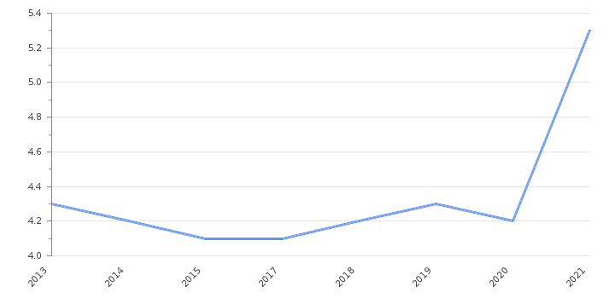

Fig 1:Bangladesh-unemployment-rate-2013-2020.

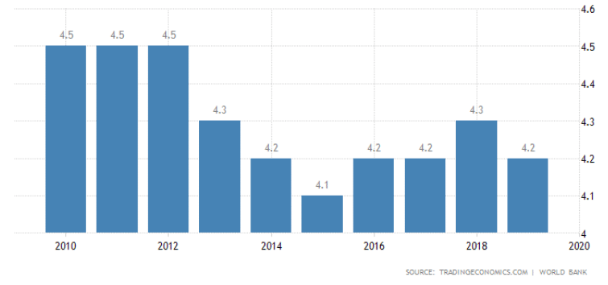

Fig 2:Unemployment rate in Bangladesh.

**Chapter 3**

**INDEX TERM**

**3.1 API**

API is the acronym for Application Programming Interface, which is a software intermediary that allows two applications to talk to each other. Each time you use an app like Facebook, send an instant message, or check the weather on your phone, you’re using an API.

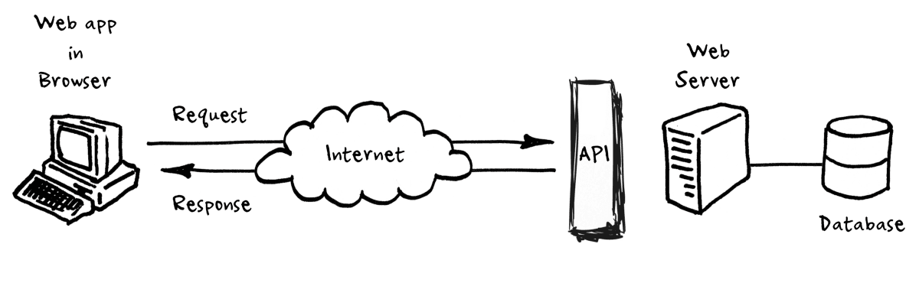

Fig 3: How API works.

**3.1.1 APIs**

We used a lot of API in our project.

**Programmable Search Engine:** Programmable Search Engine let us include a search engine on our website to help your visitors find the information they're looking for. Because Programmable Search Engine is based on Google's core search technology, we all can be confident that your users are getting high quality, relevant results.

**Geolocation API:** The Geolocation API in out project allows the user to provide their location to web applications if they so desire. For privacy reasons, the user is asked for permission to report location information. The user's operating system will prompt the user to allow location access the first time it is requested.

**3.2 Database**

**MySQL (Website):** We use the MySQL database for developing our website. MySQL Database Service is a fully managed database service to deploy cloud-native applications using the world's most popular open-source database.

**3.3 HTML**

HTML stands for Hyper Text Markup Language. We added a series of elements by HTML for designing the front end of our website which describes the structure of our Web page.

**3.4 CSS**

CSS Stands for "Cascading Style Sheet”. We used Cascading style sheets to format the layout of Web pages. It is used for define text styles, table sizes, and other aspects of Webpages that previously could only be defined in a page's HTML.

**3.5 Bootstrap**

A bootstrap program is the first code that is executed when the computer system is started. The entire operating system depends on the bootstrap program to work correctly as it loads the operating system. We apply Bootstrap as an open-source toolkit HTML, CSS, and JavaScript framework for developing responsive web design.

**Chapter 4**

**LITERATURE SURVEY**

**4.1 Related Work**

Online job portals are designed to make it easier for recruiters and job seeker to come at a common platform. By following some simple steps, a job seeker can submit his/her CV and the rest is to be done by that job portal. The system of the portal try to match your job specifications with the companies having vacancies. The matchmaking side include important object in a job profile like the location preference, preference for certain industry or role, salary preferred, qualifications.Online job portals provide the facility of applying online. Applying candidates get interview calls only when their CV is shortlisted.

The website can search the suitable job for the jobseeker.We solve this problem by using a search option so that the job seeker search the available option for the desire post.By using the keywords in the database,this search result will show the most preferable job for the seeker. .In the database, we will use sql for job portal and location. For job seeker, In this project we will use PHP to apply jobs, search, notification.

To find a better job one can check on the salary,working hour and weekly working hour of the company.Also there are well known top ranked company in Bangladesh.The job seeker can apply for those company as they already provide the best opportunity for the employees.

[4]The study finds 78% of seasoned job seekers used the internet to search for employment opportunities, versus only 64% of recent graduates. More experience job-seekers were also more likely to register on more than one job portal and relied less on social networks like relatives,friends.

[5]In the early 2000,Eight young business and IT professional started a venture called Bdjobs.com Ltd.This is the first career management site in the country.

[6]SkillJobshas been developed focusing on our past 20+ experiences in the Global Job Market, particularly, the latest trends in the job field, skill matrix, technological advancement, demand and expectations of modern organizations. The organization has been originated from Jobsbd.com, the first ever job portal in Bangladesh and later renamed as SkillJobs simply to express the focus of the organizations and to concentrate more on its service patterns. The idea was to make our position more unique and specific while we work! Skill.jobs has started its operation simultaneously in Bangladesh and Malaysia and soon it’s going to start same in Australia UK and UAE.

Chakri.com is another online based job provider in Bangladesh. Chakri.com is the top most transparent career community in Bangladesh that is changing the way people find jobs, and companies recruit top talent.[7]A portal improves functionality and flexibility to cater for various classes of users . Many companies have realized the need to change employment or recruitment process in order tocope up with the increasingly changing technology and the large number of job seekers.(Midiwo,2015).

The internet therefore has become a popular way to recruit people. The Human Resource Information System (HRIS) is a system which has been used previously to manage employees. The efficiency and effectiveness of the Human Resource Information System enables staff to format their profile, strengths and weaknesses(Rawat,2010).[8]E-recruitment emerges as a handy and advantageous method over traditional methods of recruitment (Tong and Sivanand 2005).

The quality of people applied for a individual job is usually the main subject when measuring the effectiveness of the employment.In certain situation, The speed of hiring is also a subject and also contribute the quality hiring.In the past, Newspaper column or television advertisement handled the job hiring process and have appointed day to interview applicants.

**Chapter 5**

**METHODOLOGY & MODEL ARCHITECTURE**

**5.1 Use Case Diagram**

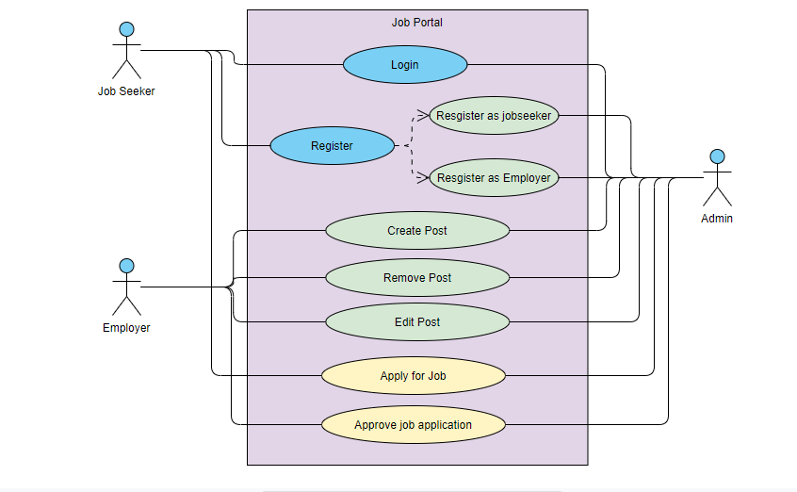

Fig 4: Use case diagram for Online Job Portal.

**5.2 Class Diagram**

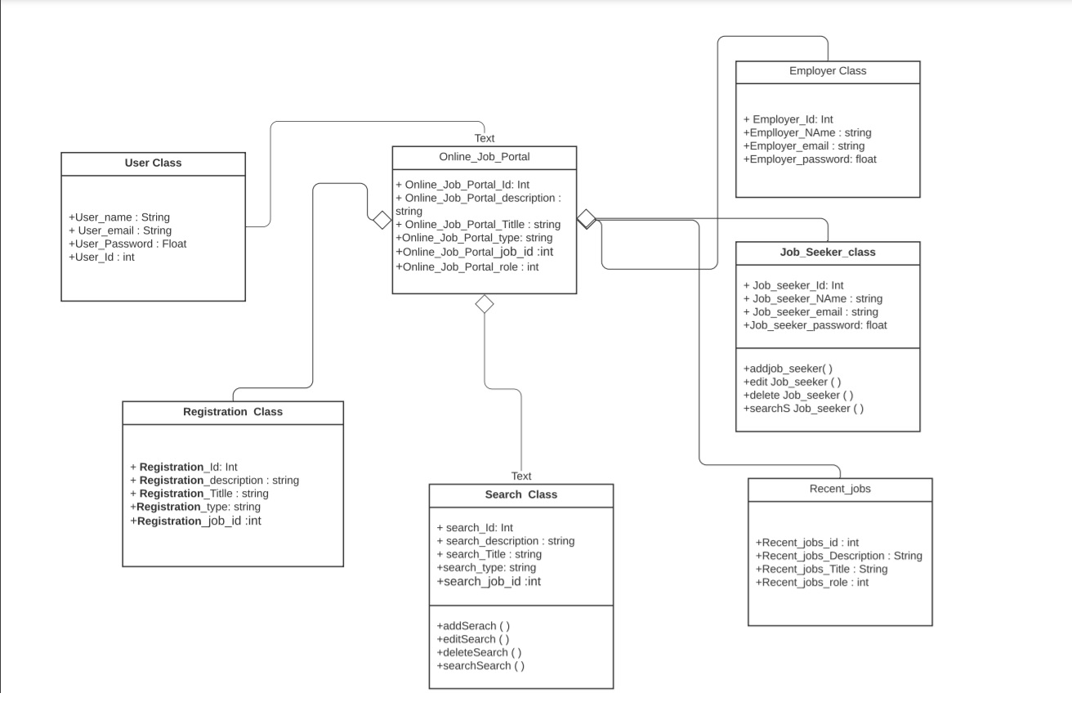Fig 5: Class diagram for Online Job Portal.

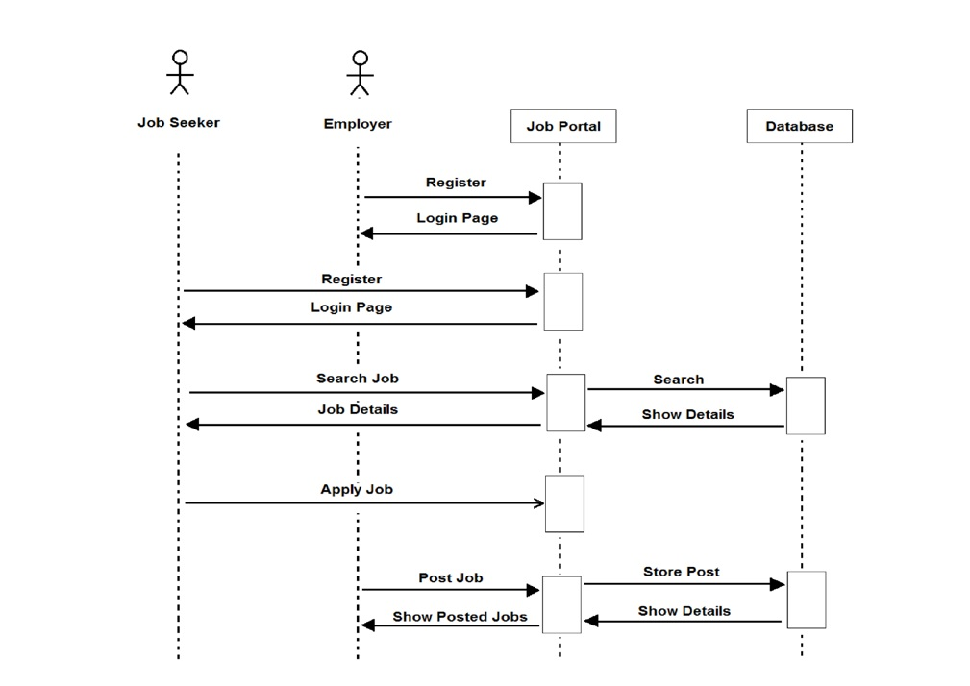**5.3 Sequence Diagram**

Fig 6: Sequence diagram for Online Job Portal.

**5.4 Activity Diagram**

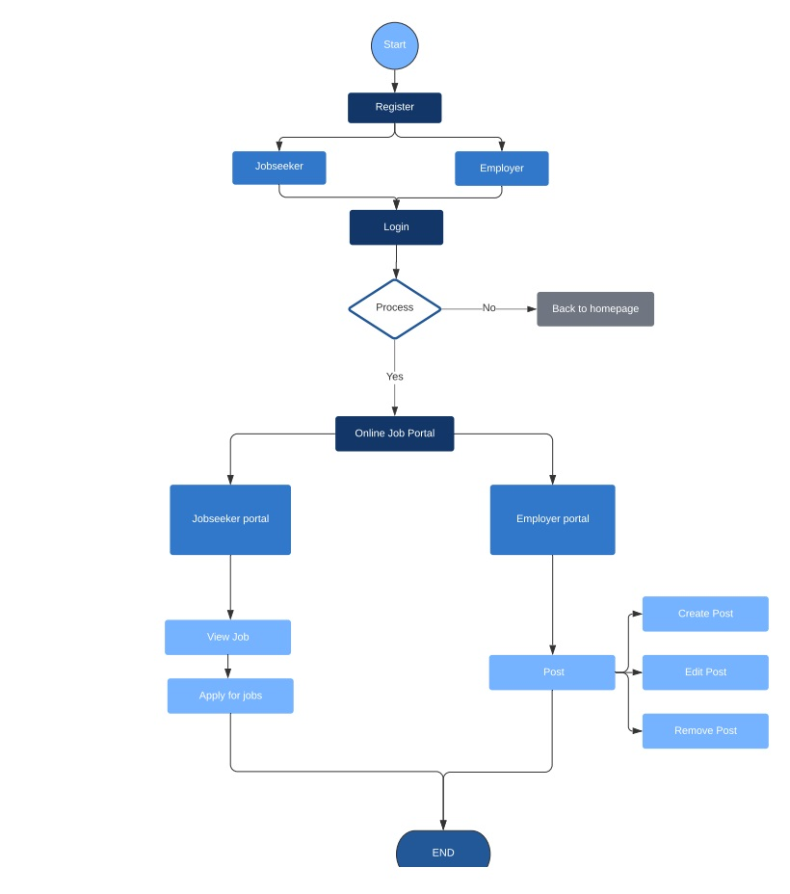

Fig 7: Activity diagram for Online Job Portal.

**Chapter 6**

**RESULT ANALYSIS**

**Homepage:**

This is the interface of our home page.

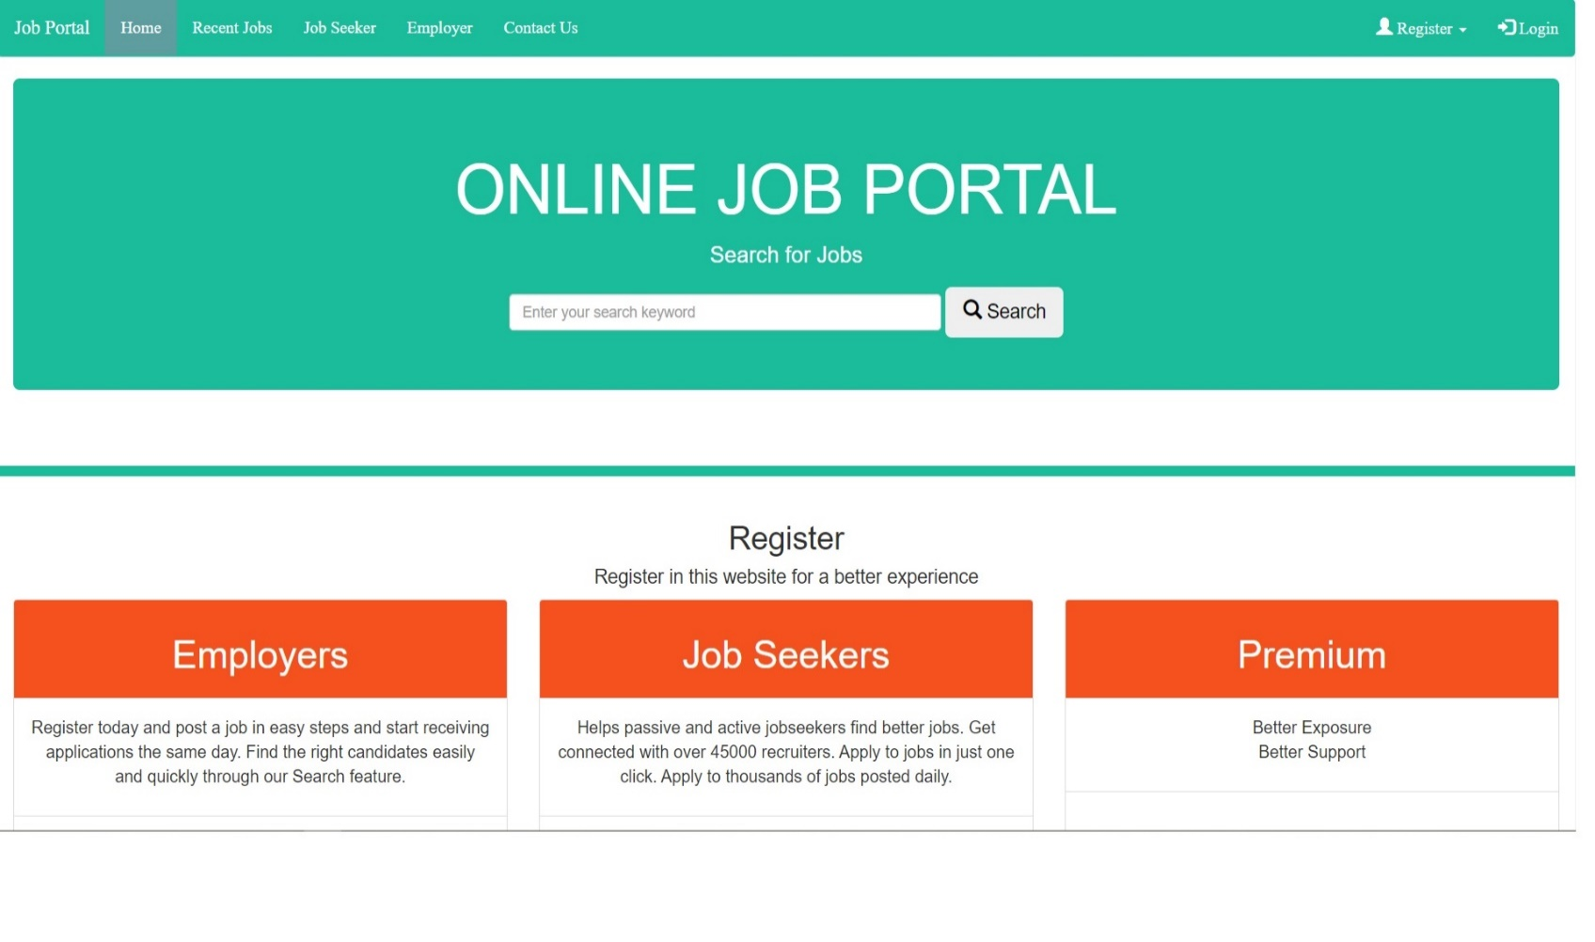

Fig 8: Homepage.

**Contact Us:**

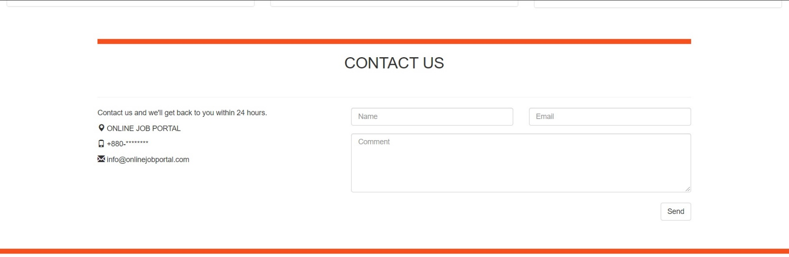Contact us page is created in case any of our user wanted to contact So they can reach us through this option.

Fig 8: Homepage.

Fig 9: Contact Us.

**Login:**

Once a user is registered,They can log in from this page and can use the further option of our web page.



Fig 10: Login.

**Register Employer:**

If any company want to register their job in our portal,They have to register their company through this page.

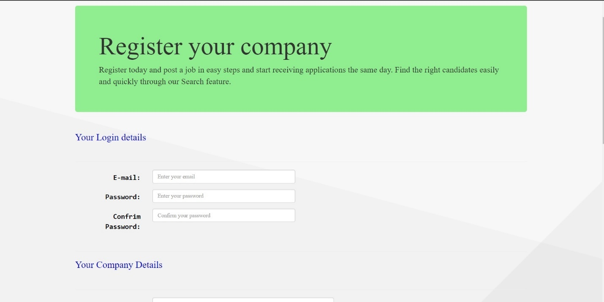

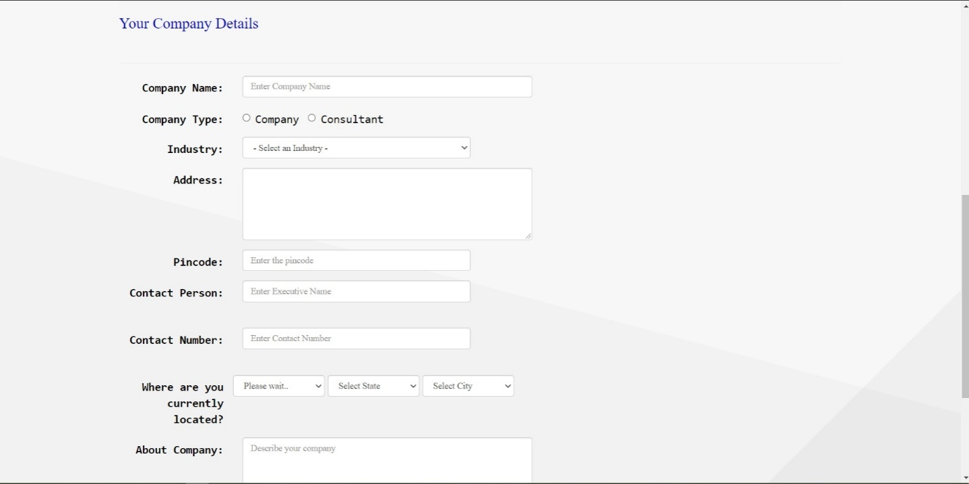

Fig 11: Employer Register.

**Register Jobseeker:**

Any job seeker who wanted to find a job from our portal.First they have register themself by using this page.

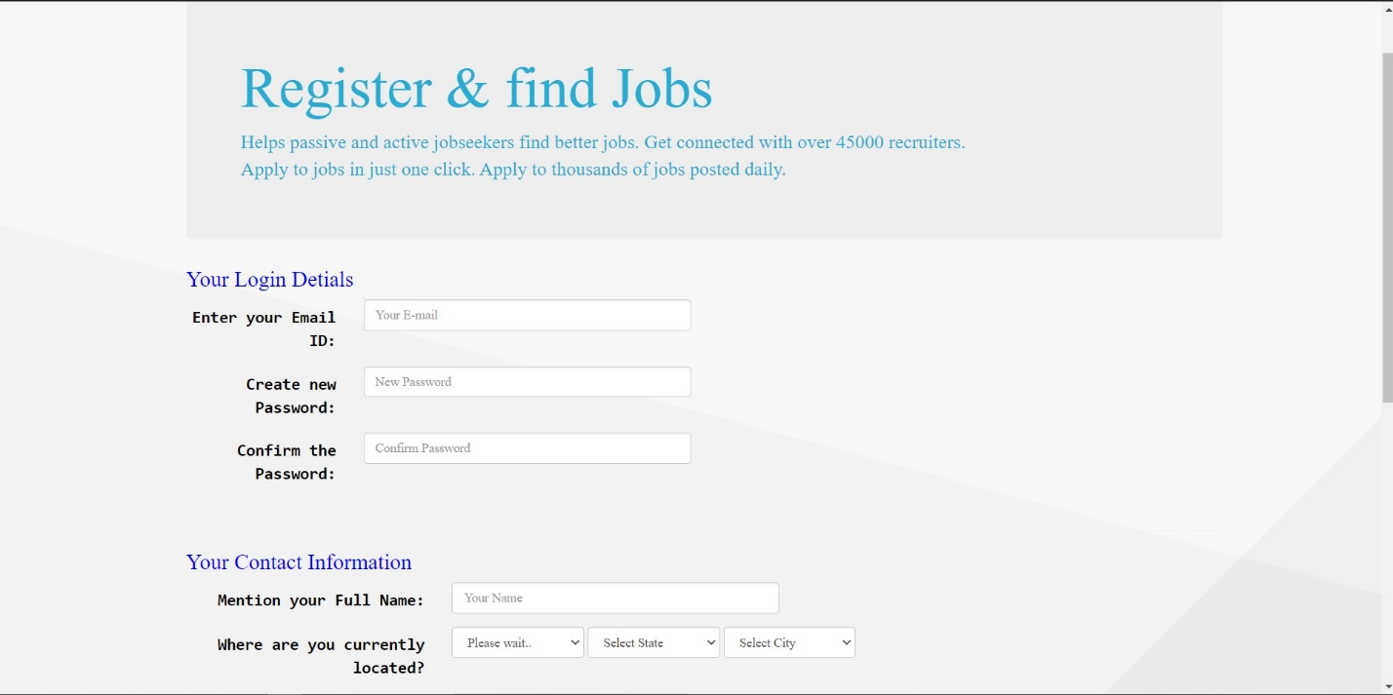

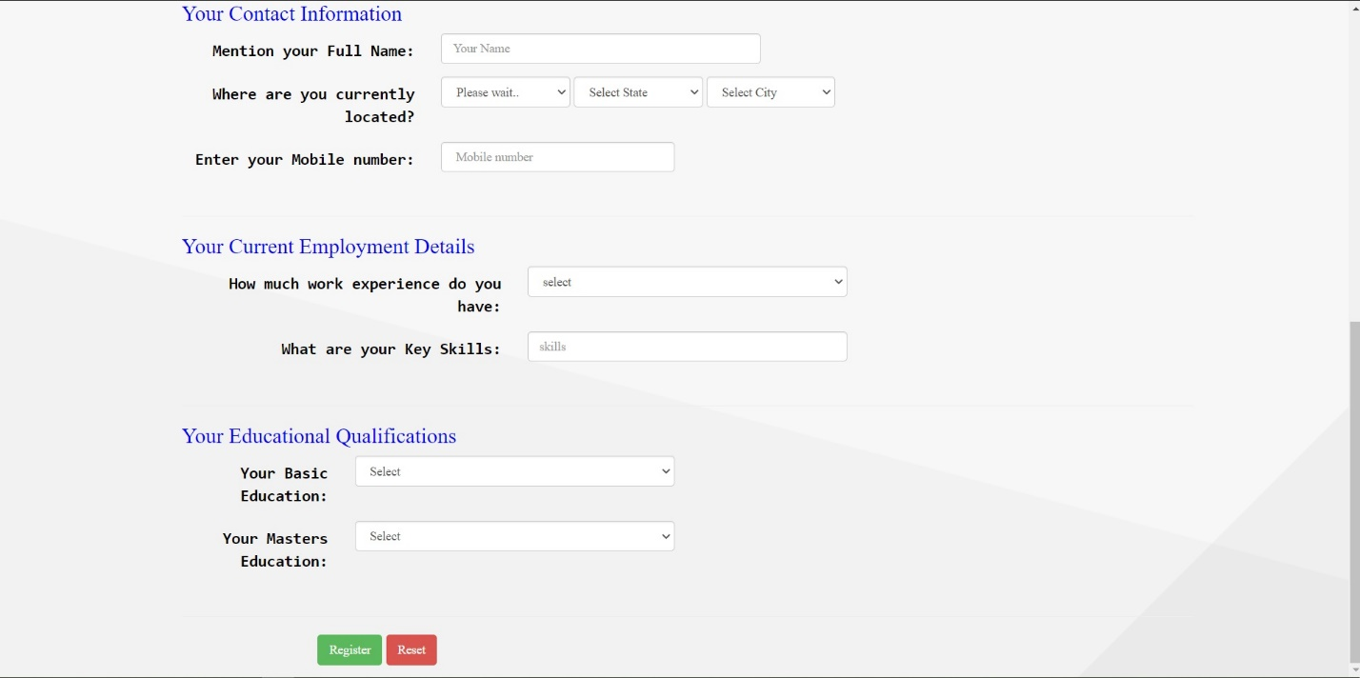

Fig 12: Jobseeker Register.

**Company’s profile:**

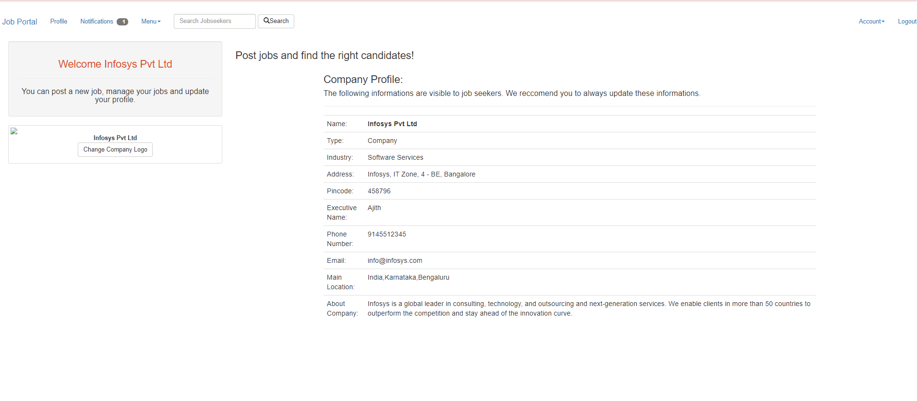A registered company’s profile will look like this.All the information will appear in this page.

Fig 13: User Interface .

**Chapter 7**

**WORKING SHEETS**

**7.1 Working Sheets**

Week 1 Class Introduction

Week 2 Project Proposals

Week 3 Detailed Presentation

Week 4 Requirement Analysis & Learning

Week 5 Learning Complete

Week 6 Database Design

Week 7 UI Complete

Week 8 Save images and logos

Week 9 Project analysis and edit

Week 10 Extra Week

Week 11 Project Report Submission & Final Demonstration

**Chapter 8**

**IMPACT**

**8.1 Social & Environmental Impact**

In the recent days we mostly depend on online activities.We used search every possible thing in online.Online sites make it so easy for us to find anything we like.Millions of people using social media sites.Online job portal saves the applicants time and energy.The interview process is quick and simple.One can apply for a job in the morning and done with the interview by the evening.Its cost nothing to post a job in the portal.Sometimes the interview process may take time due to security issues.As the company not confident enough about the applicants.Its easier than dropping CVs in every company.Companies can show promo video and benefits of working in their company to attract specific type of applicants.It is more flexible to post a job in online.Hence this is so easy for any people to search for a job. Searching job from newspaper or wall poster is difficult.Sometimes people got the wrong job and lose interest.They simply quit the job.As its way more easier so people get attracted to this which help us to decrease the unemployment rate.It will help effectively in our economy.As per research we got that the online job portal has an effective social and environmental impact.

**Chapter 9**

**PROJECT SUMMARY**

**9.1 Future Scope**

When studying about job seeking candidates there are many factors that needed consideration. The factors where narrowed down keeping in mind what is most important. The parameters chosen are quality of information, cost-efficiency, tranparency, attractiveness and effectiveness, security and confidentiality and most importantly to what degree will the candidates choose a job portal over any other medium to look for jobs. The result of the study may be helpful to resource consulting firms which work with E recruitment which will help them better their existing recruiting procedure and will also influence candidates to use job portals.

**9.2 Conclusion**

The concept of portal has emerged and it's only growing be it in any sector. Job portal is one of them that has the potential to shine through. The portal is not only mode for candidates to look for jobs but is also helpful for recruiters throughout the procedure of recruitment but its efficiency, effectiveness and candidates satisfaction is what make it a user's choice of medium. Research was done keeping many factors in mind. The parameters chosen were quality of information, cost-efficiency, transparency, attractiveness and effectiveness, security and confidentiality and most importantly to what degree will the candidates choose a job portal over any other medium to look for jobs. During our analysis we found that job seeker prioritizedtransparency of information, security, quality of information and attractiveness of the portal.Thus our finding and understand suggests working on these parameters to fascinate job seekers and recruiters to lean toward this platform.

**9.3 Poster**

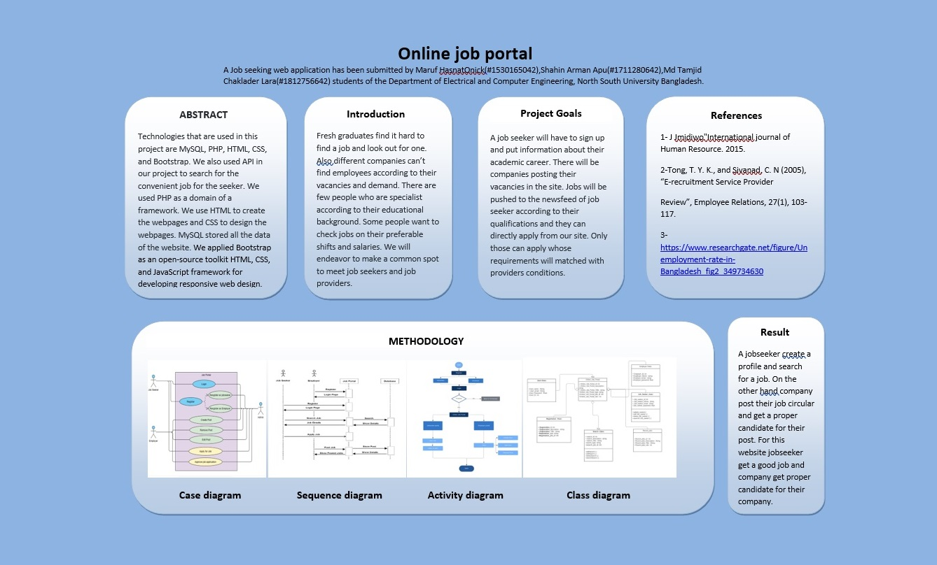

Fig 14:Poster.

**Chapter 10**

**BIBLIOGRAPHY**

**References**

[1] <https://www.researchgate.net/figure/Unemployment-rate-in-Bangladesh_fig2_349734630>

[2] <https://take-profit.org/en/statistics/unemployment-rate/bangladesh/>

[3] <https://www.statista.com/statistics/808225/unemployment-rate-in-bangladesh/#:~:text=In%202020%2C%20the%20unemployment%20rate,steady%20at%20around%204.2%20percent>.

[4] <https://www.theigc.org/blog/click-to-apply-the-impact-of-online-job-portals-on-job-search-outcomes/>

[5] <https://www.businesshaunt.com/top-jobs-and-internships-posting-websites-in-bangladesh/>

[6] <https://daffodil.family/business-ventures/ict-ventures/skill-jobs>

[7] J J midiwo"International journal of Human Resource. 2015.

[8] Tong, T. Y. K., and Sivanad, C. N (2005), “E-recruitment Service Provider Review”, Employee Relations, 27(1), 103-117.